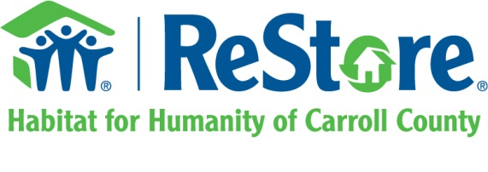
TITLE: Resource Coordinator
STATUS: Non-Exempt / Full-time
REPORTS TO: ReStore Manager
Primary Role: The Resource Coordinator will be responsible for coordinating all resources at the ReStore including, but not limited to; scheduling ReStore pickups, coordinating with third party deliveries, greet new volunteers and introduce to warehouse staff, ensure office supplies are maintained at proper levels.

Responsibilities:
Operational:
- Maintain the ReStore Pickup inbox and phone request by coordinating and scheduling all pickups performed by the ReStore Donation Ambassador.
- Maintain the ReStore Pickup Schedule by scheduling pickups logistically and ensuring the drivers time is best utilized with limited cross-county trips.
- Maintaining proper and timely communication with all donors by responding to all requests as quickly as possible and no longer than 24 hours of time of receipt.
- Coordinate/schedule pickups from donors and confirm scheduled pickup date 2 days prior to scheduled date.
- Collaborate with ReStore staff to provide support and handle logistics for ReStore staffing needs.
- Assist the Office Manager in collecting any volunteer waiver forms that have not been received electronically.
- Ensure, along with all other ReStore staff, implementation of volunteer policies and procedures.
- Assist with administrative duties as needed.
- Maintain an effective working relationship with ReStore staff, volunteers, Habitat homeowners, Corporate and residential donors, and ReStore customers.
- Other duties as assigned by ReStore Manager or Assistant Manager.
Volunteer Management:
- Guide and assist volunteers in their work, understanding that each is an individual with different capabilities.
- Along with all ReStore staff, train new volunteers to deliver high quality, consistent customer service experience in the ReStore and on pick-ups. Ensure issues are professionally resolved and reported in a timely basis.
- Provide direction for ReStore volunteers, including Institution Community Work Crew and community service volunteers.
Skills and Personal Characteristics:
- Dedication to and ability to articulate the mission and core values of Habitat for Humanity of Carroll County.
- Ability to plan, schedule, prioritize, coordinate, delegate and manage multiple work activities.
- Attention to detail and overall quality control.
- Strong interpersonal skills, dealing well with a variety of people, personalities, and backgrounds.
- Excellent written and verbal communication and public relations skills.
- Initiative and independent action demonstrated in handling tasks assigned.
- Demonstrated knowledge of operations, policies, and procedures.
- Self-sufficient and cooperative nature.
Education and Experience:
- High school diploma or GED.
- Working knowledge in Microsoft Office, including Word, Excel, and email.
- Administrative experience preferred.
- Nonprofit experience a plus.
Reports to: ReStore Manager
Employment Status: Full time, hourly position. Workdays may include Saturdays.
Salary: Competitive pay with benefits. Compensation is dependent on experience.

